Dell Rapids Lions Club
We Serve
Date: Oct 2023
Kathy Rindels
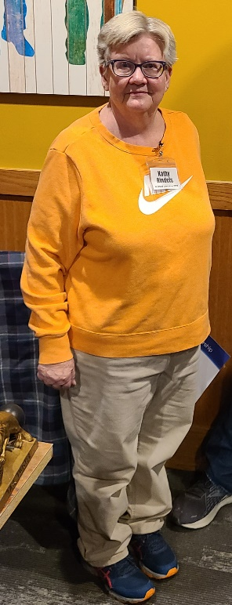

New Member Biography
I'm Kathy Rindels, a graduate of DRHS and moved back to Dell Rapids.
I moved to Madison after graduation and went to college at DSU. I graduated with a Bachelor’s of Science in Education. My first teaching position was at Crow Creek Tribal school. The school is north of Fort Thompson. There I taught middle school: science, math and language arts. I lived in Chamberlain during that time. I also lived in Pierre and taught at Stanley County.
My hobbies are gardening, quilting and reading.
I am looking forward to meeting new people in the community.

